251-196
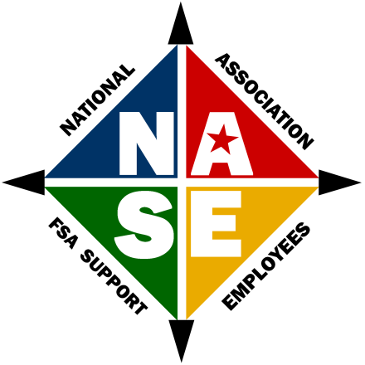

Application/Renewal for/of Membership

I, am applying for membership to the National Association of Support Employees and agree to abide by the Constitution and by-laws of the Association.

There are two ways to pay annual dues:
- PREFERRED METHOD-- I elect to have my annual dues to be withheld from my payroll in the amount of $3.00 per pay period. I have completed form FSA-444 and submitted it to my State Office on _________________ (date).
Please email this completed form along with a copy of the FSA-444 for NASE to:

Nancy J. Reiff at nancy.reiff@usda.gov

NOTE: The national dues should be loaded with a union code of ’54 and a local code of ‘0018’. If you wish to have your State Association dues also withheld from your payroll via FSA-444, please complete a separate form to withhold the amount due for your State dues and submit both forms to your State office.
- My check for $78.00 regular member or $20.00 for supportive members is attached and is issued to NASE. I also agree that I will join my State Association at this time and/or when one is established. (Renewal of dues are to be paid in July of each year following enrollment).
Mail to: Whitley Co FSA, Attn Nancy J Reiff, 788 W Connexion Way – Suite B, Columbia City, IN 46725-1047

Name:
Home Address:
Home Telephone: Home email:
Office Address:
Office Telephone: Work Email:
Birth Day and Month: ________________ Work Anniversary: (Month, Day and Year)__________________
New member ______ or Renewing your membership: Year of original membership) _____________
Sponsor’s Name___________________________
(Please list the person who contacted you about becoming a member)

